COP

ASSIGNMENT 2

Name: Harshal v Balkhande

Q1 Write a program to calculate the sum of first 10 natural number.

package assignment2;

public class Q1 {

public static void main(String[] args) {

int i,sum=0;

for(i=1;i<=10;i++)

{

sum = sum + i;

}

System.out.println("Sum of first 10 natural number is " + sum);

}

}

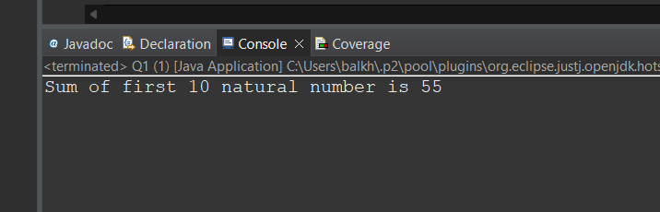

Q 2 Write a program that prompts the user to input a positive integer. It should then print the multiplication table of that number.

package assignment2;

import java.util.\*;

public class Q2 {

public static void main(String[] args) {

Scanner s = new Scanner(System.in);

System.out.println("Enter number");

int no = s.nextInt();

for(int i=1;i<10;i++)

{

System.out.println(no + "\*" + (i+1) + "=" + (no \* (i+1)));

}

}

}

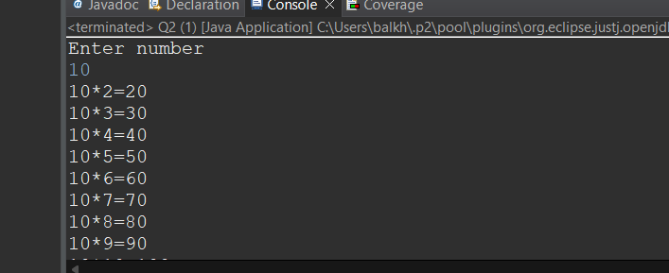

Q 3 Write a program that prompts the user to input an integer and then outputs the number with the digits reversed. For example, if the input is 12345, the output should be 54321.

package assignment2;

import java.util.\*;

public class Q3 {

public static void main(String[] args) {

int no =0;

int reverse = 0;

Scanner s = new Scanner(System.in);

System.out.println("Enter number");

no=s.nextInt();

while(no!=0)

{

reverse = reverse\*10;

reverse=reverse+no%10;

no=no/10;

}

System.out.println("Reverse input number is :" + reverse);

}

}

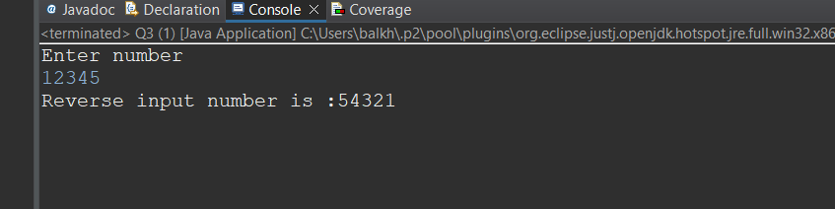

Q 4 Write a do-while loop that asks the user to enter two numbers. The numbers should be added and the sum displayed. The loop should ask the user whether he or she wishes to perform the operation again. If so, the loop should repeat; otherwise it should terminate.(while loop)

package assignment2;

import java.util.\*;

public class Q4 {

public static void main(String[] args) {

Scanner s = new Scanner(System.in);

int sum =0;

char opt;

do {

System.out.println("Enter two number");

int no1=s.nextInt();

int no2=s.nextInt();

sum =sum+no1+no2;

System.out.println("perform Another operation");

opt=s.next().charAt(0);

}while(opt=='Y'|| opt=='y');

System.out.println("sum "+ sum);

}

}

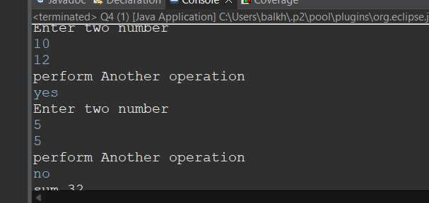

Q 5 Write a program to print out all Armstrong numbers between 1 and 500. If sum of cubes of each digit of the number is equal to the number itself, then the number is called an Armstrong number.  
For example, 153 = ( 1 \* 1 \* 1 ) + ( 5 \* 5 \* 5 ) + ( 3 \* 3 \* 3 )

package assignment2;

public class Q5 {

public static void main(String[] args) {

int n=153;

int m=n;

int rem=0;

int p=0;

while(n!=0)

{

rem =n%10;

//p+=rem\*rem\*rem;

p+=Math.pow(rem, 3);

System.out.println(rem);

n=n/10;

}

if(m==p)

System.out.println("number is armstrong");

else

System.out.println("not armstrong");

}

}

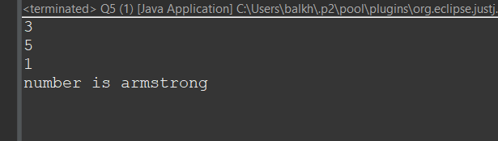

Q 6 Write a program to print Fibonacci series of n terms where n is input by user :  
0 1 1 2 3 5 8 13 24 .....  
  
package assignment2;

import java.util.\*;

public class Q6 {

public static void main(String[] args) {

int count,no1 =0,no2 =1;

Scanner s = new Scanner(System.in);

System.out.println("Enter number");

count = s.nextInt();

System.out.print("fibonacci series of " +count+ "number:");

int i=1;

while(i<=count)

{

System.out.print(no1+" ");

int sumtwo = no1+no2;

no1=no2;

no2=sumtwo;

i++;

}

}

}

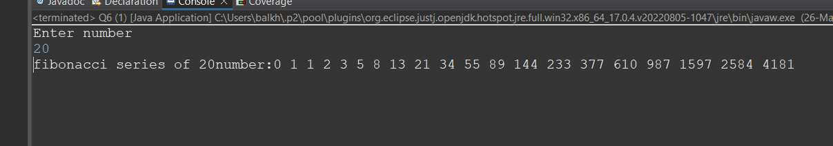

Q 7 Write a program to print following :  
i)  
  
\*\*\*\*\*\*\*\*\*\*  
\*\*\*\*\*\*\*\*\*\*  
\*\*\*\*\*\*\*\*\*\*  
\*\*\*\*\*\*\*\*\*\*

package assignment2;

public class Q7i {

public static void main(String[] args) {

for(int i=1;i<=4;i++)

{

for(int j=1;j<=10;j++)

{

System.out.print("\*");

}

System.out.println();

}

}

}

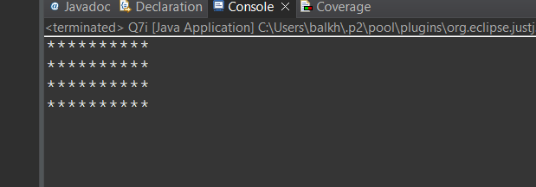

ii)  
  
\*  
\*\*  
\*\*\*  
\*\*\*\*  
\*\*\*\*\*  
  
package assignment2;

public class Q7ii {

public static void main(String[] args) {

for(int i=1;i<=5;i++)

{

for(int j=1;j<=i;j++)

{

System.out.print("\*");

}

System.out.println();

}

}

}

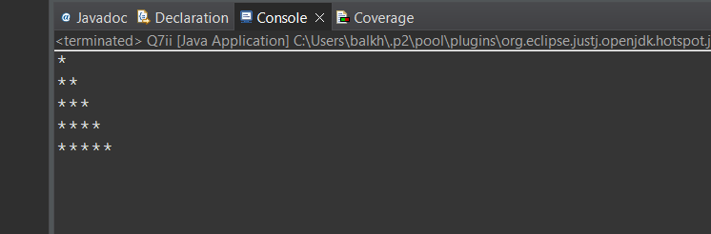

iii)  
  
 \*  
 \* \*  
 \* \* \*  
 \* \* \* \*  
  
package assignment2;

public class Q7iii {

public static void main(String[] args) {

for(int i=0;i<5;i++)

{

for(int j=1;j<5-i;j++)

{

System.out.print(" ");

}

for(int k=0;k<=i;k++)

{

System.out.print("\*");

System.out.print(" ");

}

System.out.println();

}

}

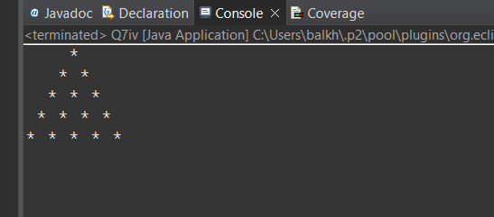

iv)  
  
 \*  
 \*\*\*  
 \*\*\*\*\*  
 \*\*\*\*\*\*\*  
\*\*\*\*\*\*\*\*\*  
package assignment2;

public class Q7iv {

public static void main(String[] args)

for(int i=0;i<5;i++)

{

for(int j=0;j<5-i;j++)

{

System.out.print(" ");

}

for(int k=0;k<2\*i+1;k++) {

System.out.print("\*");

}

System.out.println();

}

}

}

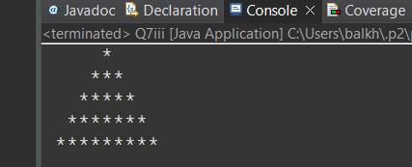

v)  
  
 1  
 222  
 33333  
 4444444  
555555555

package assignment2;

public class Q7v {

public static void main(String[] args) {

int m=0;

for(int i=0;i<5;i++)

{

m++;

for(int j=0;j<5-i;j++)

{

System.out.print(" ");

}

for(int k=0;k<2\*i+1;k++) {

System.out.print(m);

}

System.out.println();

}

}

}

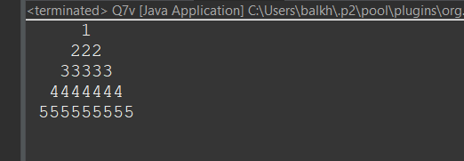

vi ) ABCDEEDCBA  
 ABCD DCBA  
 ABC CBA  
 AB BA  
 A A

public static void main(String[] args) {

int space=0;

char ch='A';

for(int i=5;i>=1;i--)

{

for(int j=1;j<=i;j++) {

System.out.print(ch);

ch++;

}

for(int k=0;k<space;k++) {

System.out.print(" ");

}

for(int l=1;l<=i;l++)

{ch--;

System.out.print(ch);

}

System.out.println();

space++;

}

}

}

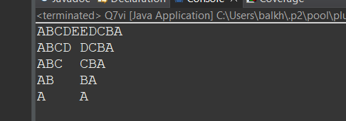

Q 8 Write a program in java to find the sum of the even and odd digits of the number which is given as input.

package assignment2;

import java.util.\*;

public class Q8 {

public static void main(String[] args) {

int no,i,sumE =0,sumO =0;

Scanner s = new Scanner(System.in);

System.out.println("enter the number");

no=s.nextInt();

for(i=1;i<=no;i++)

{

if(i%2==0)

{

sumE=sumE+i;

}

else {

sumO=sumO+i;

}

}

System.out.println("sum of even no " + no + " = " + sumE);

System.out.println("sum of odd no " + no + " = " + sumO);

}

}

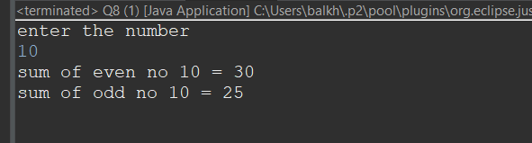

Q9 Write a program to check if given number is prime or not

package assignment2;

import java.util.\*;

public class Q9 {

public static void main(String[] args) {

int input;

Scanner s = new Scanner(System.in);

System.out.println("Enter the Number");

input = s.nextInt();

boolean prime = false;

for(int i=2;i<=input/2;++i)

{ if(input % i==0)

{

prime = true;

break; }

}

if(!prime)

System.out.println("The number " + input + " is a prime number");

else {

System.out.println("The number " + input + " is not a prime number");

}

}

}

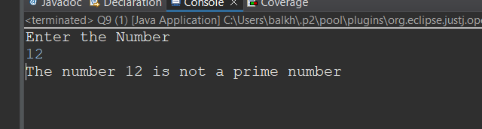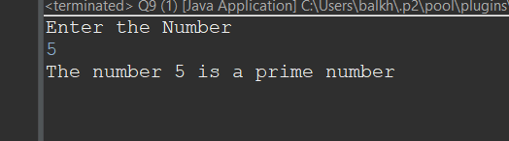

Q 10 write a program to print prime numbers between 2 to 20.

package assignment2;

public class Q10 {

public static void main(String[] args) {

int no=20, count;

for(int i=2;i<=no;i++)

{

count = 0;

for(int j=2;j<=i/2;j++)

{

if(i%j==0)

{

count++;

break;

}

}

if(count==0)

{

System.out.println(i);

}

}

}

}

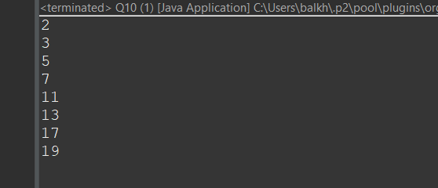

Q 11 Write program to find largest among three numbers

package assignment2;

public class Q11 {

public static void main(String[] args) {

int a = 15;

int b = 99;

int c = 77;

int max = (a>=b)? ((a>=c)?a:c):((b>=c)?b:c);

System.out.println("Largest Number="+max);

}

}

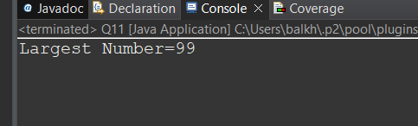

Q 20 Write a program to find sum of all integers greater than 100 and less than 200 that are divisible by 7

package assignment2;

public class Q20 {

public static void main(String[] args) {

int sum=0,count=0;

for(int i=101;i<=200;i++)

{

if(i%7==0)

{

sum = sum +i;

count++;

}

}

System.out.println("The sum of all intergers number between 100 to 200 are divisible by 7 is " + sum);

System.out.println("Total number between 100 to 200 are divisible by 7 is : " + count)

}

}

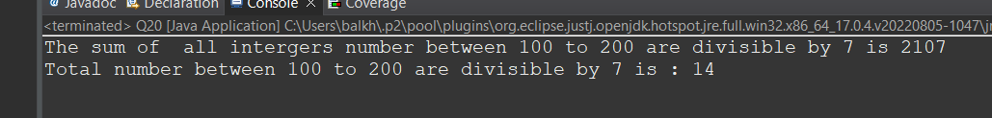

Q 21 8. Write a Java program to print numbers between 1 to 100 which are divisible by 3, 5 and by both.

package assignment2;

public class Q21 {

public static void main(String[] args) {

System.out.println("\nDivided by 3: ");

for (int i=1; i<100; i++) {

if (i%3==0)

System.out.print(i +", ");

}

System.out.println("\n\nDivided by 5: ");

for (int i=1; i<100; i++) {

if (i%5==0) System.out.print(i +", ");

}

System.out.println("\n\nDivided by 3 & 5: ");

for (int i=1; i<100; i++) {

if (i%3==0 && i%5==0) System.out.print(i +", ");

}

System.out.println("\n");

}

}

}

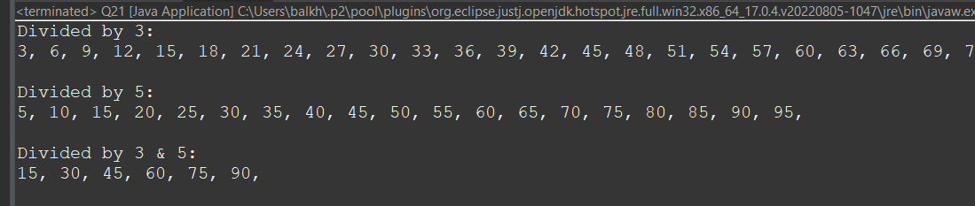

Q 22 create a menu driven application in java that show  
 "Add" Add two number  
 "subtract" Subtract two number  
 "Multiple" Multiple two numbers  
 "Exit " Exit

package assignment2;

import java.util.\*;

public class Q22 {

public static void main(String[] args) {

Scanner s = new Scanner(System.in);

System.out.println("Enter 1st no ");

int n1=s.nextInt();

System.out.println("Enter 2nd no");

int n2=s.nextInt();

System.out.println("Enter the choice");

String choice=s.next();

switch(choice)

{

case "Add" : System.out.println(":sum of two number is: "+(n1+n2));

break;

case "sub" : System.out.println("sub of two number is : "+(n1-n2));

break;

case "multiply" : System.out.println("multiply of two number : "+(n1\*n2));

break;

case "Exit" : System.out.println("Exit");

break;

default : System.out.println("sorry try again again");

}

}

}

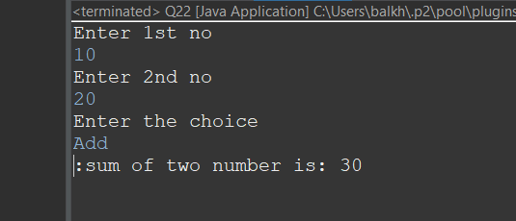

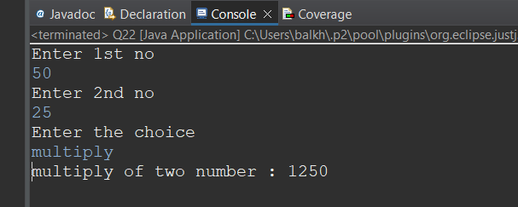

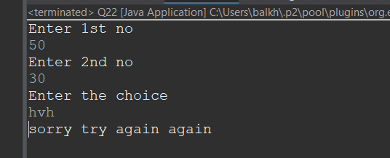

Q 23 Write a program to display first 1 to 20 even number on screen . Terminate the program when number 16 is found using break command .

package assignment2;

public class Q23 {

public static void main(String[] args) {

for(int i=1;i<=20;i++ )

{

if(i%2==0)

{

System.out.println(i);

if(i==16)

break;

}

}

}

}

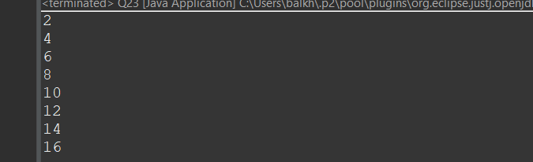

Q 24 Write a Java program that accepts two double variables and test if both strictly between 0 and 1 and false otherwise.

package assignment2;

import java.util.\*;

public class Q24 {

public static void main(String[] args) {

Scanner s = new Scanner(System.in);

System.out.println("Input first number");

double d1=s.nextDouble();

System.out.println("Input second number");

double d2=s.nextDouble();

System.out.println(d1>0 && d1<1 && d2>0 && d2<1);

}

}  
